

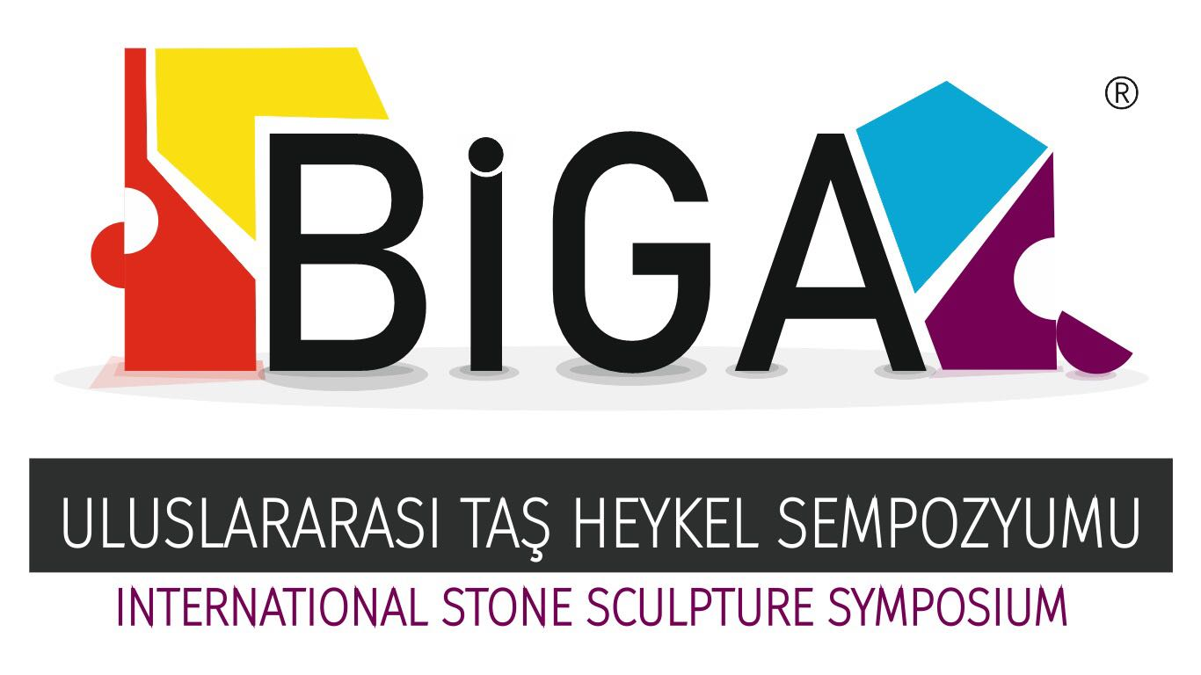

SYMPOSIUM SPECIFICATION

AIM
Biga International Stone Sculpture Symposium will be organized by Biga Governorate in 2018.Aims of symposium are to get our country’s artists and the other countries’ artists together, to get artists with artlovers and the public together, to carry on a tradition of sculpture, to support artists, to introduce Biga to abroad and our country, and to give our district well-qualified artistic work, to contribute our country’s artistic deposition.

OVERVIEW
Topic 1. Biga International Stone Sculpture Symposium will be performed between the date of 03/09/2018 - 28/09/2018 in Biga.

Topic 2. Artists who are going to participate in symposium will identify by the selective council of Biga Governor being predicated on application files which were sent by artists. At the end of the symposium, each of the artists will be given a certificate of attendance by Biga Governor.

Topic 3. Ten artists are going to participate in the symposium. Suggestion of the selective council, if it is necessary with the agreement of administration, the number of participants are changed.

Topic 4. At the most ten students who graduated from the Department of Sculpture in the Faculty of Fine Arts of universities or graduate, doctorate are going to be tasked as an assistant in the symposium. Artists who were selected can bring their assistants such as indicating at the topic 10.

Topic 5. White marbles will be used as a sculpture material.

Topic 6. The theme of the symposium was (TROIA)

Topic 7. The property of Works is owned to the Governor of Biga. Setting Works at the museum or moving them for temporal exhibitions are of the district Governor own initiative. Artist lets be viewing his/her Works and his/her working process. Governor of Biga has the rights of using views for publicitiy.

Topic 8. Artists’ Works performing during the symposium are going to be set to the places determined by Symposium Organizing Committee and the Governorship of Biga.
The place which will be displayed the sculpture in is determined by Arrangement Committee and Governorship of Biga.Artists have to respect a hundred percent the Project which they committed. ( the evaluation will be make a duty on the Project.)

Topic 9. Artists’ transportation, breakfast, lunch, dinner and accommodation attending to the symposium will be supplied by Governorship of Biga.

Topic 10. Only one person can escort with each artist attending to the symposium. Companions’ transporation, breakfast, lunch, dinner and accommodation provided that they have to stay at the same room will be supplied. Companions’ transportation expenses are owned by artist’s themselves, and they won’t pay any extra payment for their work.

Topic 11. Transportation service involves the transportation from bus station to the symposium place and economic class for all artists, return ticket of plane or bus. Each Artist must supply for her/his ticket, when he/she comes, her/his money will be paid ( with the first per diem fee).

Topic 12. If each artist performs her/his own work within specified time and place will be paid for net 10.000TL as general expenses and copyright. Part of the required amount of 4.000TL will be paid at the end of the first week of the symposium and the remaining 6.000TL will be paid to the artists at the end of the symposium.

Topic 13. Although it won the right to attend the symposium, artists stating which won’t be able to come or within in 3 days starting from the date of symposium, if they haven’t any excuse and they don’t stand by at the symposium , their participation will be cancelled.

Topic 14. Artists are responsible for by respecting to the symposium timetable and standing at the symposium court within working hours. In case of In case of necessity of separation, they bound by declaring the excuse to the Symposium Organizing Committee Presidency. In exceptional circumstances developed the Symposium Organizing Committee will evaluate.

Topic 15. Çanakkale and Biga trip will be organized for the participating artists.( Artists who want to can come )

Topic 16. Artist-management relationship will be carried out by İsmail SATILMIŞ, Chairman of the Organizing Committee.

Topic 17. The artists will bring their technical equipment they will use during the symposium. They are responsible for the shipping costs of the technical material.

APPLICATION

Topic 1. The files which will be on the selection of artists will participate in the symposium will include the following items:

- Application form,
- The current residence address of the artist, birth place and date, telephone number, e-mail address,
- not exceeding one typed page, explaining the most important event, 10 artists, participated in the curriculum vitae in English or Turkish photo,
- the visual document which identifies the past five artworks of the artists,
- Artworks showing different angels which artists will performed in the symposium, model photos,
- Installation schema,
- If there is, the additional material used in sculpture,
- If artist thinks it necessary,there can stand brief explanation in English or Turkish about the work,
- Each artist has to apply %100 of sculpture design of the proposed form.

NOT: It is necessary to be signed in entry form and specification without any change. The work of artists that do not comply with the specification will be stopped.

Topic 2: The application file containing the above information and not exceeding a total of 1.5 MB must be submitted by email on Wednesday 20/06/2018, at 17: 00 at the latest, to the e-mail address below. Applications submitted via email will only be accepted. Incomplete applications will not be considered. The first phase of the evaluation will be made by Organizing Committee and the second and third phases by the Selection Committee.

Application Address: bigaheykelsempozyumu@gmail.com

Topic 3: The documents in the application file can be used in press releases and other publications to be printed like as catalog.

Working Conditions

Topic 1. Governor of Biga will give each artist cutted marble block/s in the size desired by the artist (Final version of the artwork will not be smaller than 3 meters). In addition, installation of the artworks, pedestal and necessary materials for the these will be covered by the Governor of Biga if they are specified in the application file. Costs and technical solutions in the use of additional materials other than installation belongs to the artist.

Topic 2. 220V electricity, extension cords, compressor for pneumatic tools with water cannons and canopy with its extension hose will be supplied for the artists in the symposium place.

Topic 3. The artists are responsible for arranging their own accident insurance.

Topic 4. Symposium will take place outdoors. Artists must be prepared for the unexpected weather conditions like rain and wind.

Topic 5. If artworks can not be performed within the symposium time in case of any reason, the decision of Governor of Biga and the Symposium Committee gets implemented and artists could not claim a right in this regard agrees by signing this specification.

Symposium Calendar
20.06.2018 – Symposium application deadline
22.06.2018 – Jury gathering
25.06.2018 – The results of the application to be notified by e-mail.
03.08.2018 – Deadline to inform for arrival and departure details of the participant artists.
02.09.2018 – Settlement of the Artist
03.09.2018 – The meeting of Artists and the start of the Symposium
28.09.2018 – Closing ceremony.
30.09.2018 – Departure from Biga.

The artists who have applied to participate in this symposium are deemed to have accepted the symposium specifications and calendar.

Name and Surname:
Date:
Signature:

